DIS-Eur-Spain-Early Chalcolithic-Plaques and Amulet-3500 BCE

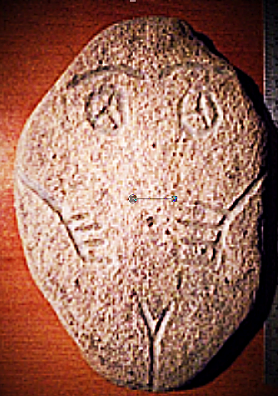 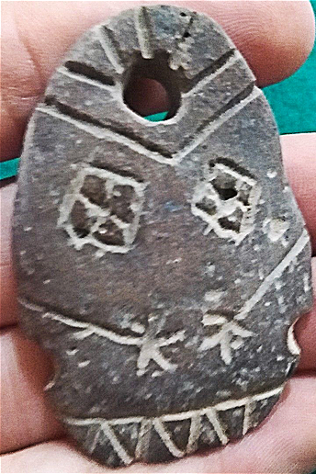 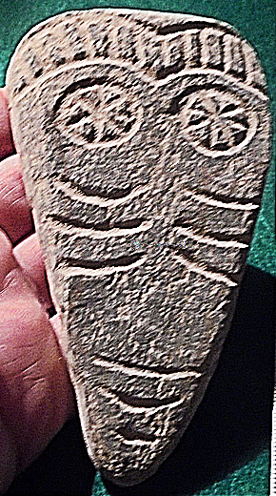

**Fig. 1. Formal Label: sw Iberia, Early Chalcolithic Female Anthropomorph Plaque, Limestone-ca 3500 BCE**

**Fig. 2. Formal Label: sw Iberia, Early Chalcolithic Female Anthropomorph Amulet, Limestone-ca 3500 BCE**

**Fig. 3. Formal Label: sw Iberia, Early Chalcolithic Male Anthropomorph Plaque, Limestone-ca 3500 BCE**

**Accession Numbers:**

**LC Classification:** GN776

**Date or Time Horizon:** 3500 BCE

**Geographical Area:** sw Iberia

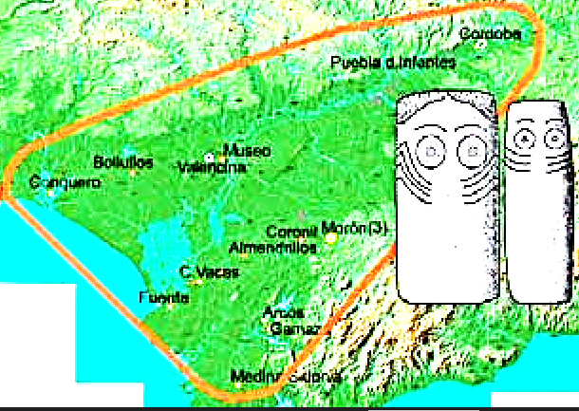

**Map:** Chalcolithic SW Iberian Plaques.

**Cultural Affiliation:** Chalcolithic

**Medium:** Limestone

**Dimensions:   
Weight:**

**Provenance: David Vosez Garcia, Francia no. 20, cp 28916, Lecones, Madrid, Spain.**

**Condition:** Excellent condition.

**Discussion:** Figures 1 and 2 are Chalcolithic limestone plaques of abstract female anthropomorphs determined by the “V”-shape (vulva) at the conjoining of theirs legs. The eyes are distinctively rendered as round orbs with internal geometrical triangular and quadrilateral lines as though suggesting a trance state. The schematic arms and hands (with only four fingers) are placed in a position that suggests the hands are holding the female’s breasts with the thumbs hidden behind the breasts as though offering milk. This example represents an artistic endeavor at the initial stages of sedentary life on the southwestern Iberian Peninsula to symbolize the need of managed fertility in the form of female energy symbolized in a schematized anthropomorph who is suggestively in charge of the fertility of the land, the crops, the herded animals and people, all of which are conjoined together in the new experiment of managed sedentary life. Figure 3 is of a male anthropomorph (i.e., without the “V” geometric). He also has the eyes distinctively rendered as round orbs with internal geometrical lines as though suggesting a trance state. He has no arms and only three fingers, and he sports a combed hairdo. His role suggests one of a suppliant rather than that of an offerant as do the Figures 1 and 2.

**References:**

Gomes, Mário Varela. 2008. “Castelo Belinho (Algarve, Portugal) and the first southwest Iberian villages.” In Mariana Diniz, ed., and International Union of Prehistoric and Protohistoric Sciences, World Congress, eds. *The Early Neolithic in the Iberian Peninsula: regional and transregional components = Le Néolithique ancien dans la péninsule Ibérique: les éléments regionaux et transregionaux*. BAR international series, 1857. Oxford, England: Archaeopress.

Lisboa, I. M. G. 1985. "Meaning and messages: mapping style in the Iberian Chalcolithic." *Cambridge Archaeological Review* **4**(2): 181-196.

Pinto, A. M. and J. S. Pinto. 1978. “Problemas de análise descritiva de placas de xisto gravadas do megalitismo português,” 1a *Mesa-Redonda Sobre o Neolítico e o Calcolítico em Portugal.* Porto.

|  |
| --- |
|  |